1. ‘Connection Refused’ related error for RPC HTTP API IPFS.
   1. https://devops.stackexchange.com/questions/15108/why-do-i-get-connection-refused-when-attempting-to-connect-to-ipfs-api-using-h
2. ERR_BLOCKED_BY_CLIENT || ERR_ADDRESSED_INVALID  
   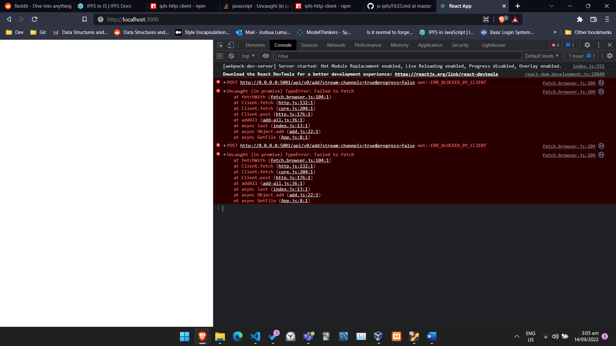A screenshot of a computer

   Description automatically generated
3. 